Insert your name, centre number and candidate number into the header above.
Save this evidence document as evidence_ followed by your centre number_ candidate number, for example: evidence_ zz999_9999.doc
Screenshots or program listings must be copied into appropriate cells in the following tables.
Examiners must be able to read the contents, including any screenshots, without the use of a magnifying glass. Answers that are not readable or are missing will not be awarded any marks.
Save this evidence document at regular intervals, for example every 10 minutes.
Question 1
Part 1(a)
Jobs = [] # global 2 dimentional array of type integer, 100 by 2 elements
NumberOfJobs = 0 # global integer

Part 1(b)
def Initialise():
global Jobs
global NumberOfJobs
for i in range(0, 100):
Jobs.append([-1, -1])
NumberOfJobs = 0

Part 1(c)
def AddJob(JobNumber, Priority):
global Jobs
global NumberOfJobs
if NumberOfJobs == 100:
print("Not added") # our array is full
else:
Jobs[NumberOfJobs] = [JobNumber, Priority]
print("Added")
NumberOfJobs += 1

Part 1(d)
Initialise()
AddJob(12, 10)
AddJob(526, 9)
AddJob(33, 8)
AddJob(12, 9)
AddJob(78, 1)

Part 1(e)
# e)
# PLEASE TAKE A LOOK AT THIS AGAIN
# since i have no idea about this, in the exam,
# use something like .sort() and continue to get marks for the others
# and also the final mark for the screen shot
def InsertionSort():
global Jobs
global NumberOfJobs
for I in range(1, NumberOfJobs):
Current1 = Jobs[I][0]
Current2 = Jobs[I][1]
while I > 0 and Jobs[I-1][1] > Current2:
Jobs[I][0] = Jobs[I-1][0]
Jobs[I][1] = Jobs[I-1][1]
I = I - 1
Jobs[I][0] = Current1
Jobs[I][1] = Current2
# marks are given as follows:
# Procedure header (and end where appropriate)
# • Outer loop through all 5 elements / number of jobs …
# • … inner loop through array elements …
# • …and comparing priority (second index) …
# • …moving the elements up and inserting correctly

Part 1(f)
def PrintArray():
global Jobs
global NumberOfJobs
for i in range(0, NumberOfJobs):
element = Jobs[i]
print(f"{element[0]} priority {element[1]}")

Part 1(g)(i)
InsertionSort()
PrintArray()

Part 1(g)(ii)
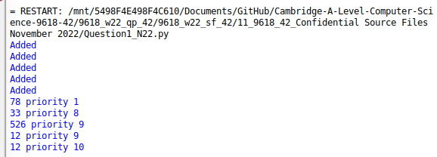

Question 2
Part 2(a)
import typing # for type hinting

class Character:
def __init__(self, Name: str, XCoordinate: int, YCoordinate: int) -> None:
self.__Name: str = Name
self.__XCoordinate: int = XCoordinate
self.__YCoordinate: int = YCoordinate

Part 2(b)
def GetName(self) -> str:
return self.__Name

def GetX(self) -> int:
return self.__XCoordinate

def GetY(self) -> int:
return self.__YCoordinate

Part 2(c)
def ChangePosition(self, XChange: int = 0, YChange: int = 0) -> None:
self.__XCoordinate += XChange
self.__YCoordinate += YChange

Part 2(d)
Characters: typing.List[Character] = []
NoCharacters: int = 10
try:
with open("Characters.txt", "r", encoding="utf-8") as _file:
for i in range(0, NoCharacters):
Name = _file.readline().strip()
XCoordinate = int(_file.readline().strip())
YCoordinate = int(_file.readline().strip())
Characters.append(
Character(
Name=Name,
XCoordinate=XCoordinate,
YCoordinate=YCoordinate
)
)

except (IOError, FileNotFoundError):
print("File not found!")
except Exception as e:
print(f"Error: {e}")

Part 2(e)
SearchedUserIndex: int = -1
while True:
UCharName = input("[?] Enter character name: ").strip()
for i in range(0, 10):
if UCharName == Characters[i].GetName():
SearchedUserIndex = i
break
else:
print("Please enter a valid name!")
continue
break

Part 2(f)
while True:
ULetter = input("[?] Enter letter to change position [A/W/S/D]: ").lower().strip()
if ULetter == "a":
Characters[SearchedUserIndex].ChangePosition(XChange=-1, YChange=0)
break
elif ULetter == "w":
Characters[SearchedUserIndex].ChangePosition(XChange=0, YChange=1)
break
elif ULetter == "s":
Characters[SearchedUserIndex].ChangePosition(XChange=0, YChange=-1)
break
elif ULetter == "d":
Characters[SearchedUserIndex].ChangePosition(XChange=1, YChange=0)
break
else:
print("Please enter a valid letter! [A/W/S/D]")

Part 2(g)(i)
print(f"{Characters[SearchedUserIndex].GetName()} has changed coordinates to X = {Characters[SearchedUserIndex].GetX()} and Y = {Characters[SearchedUserIndex].GetY()}")

Part 2(g)(ii)
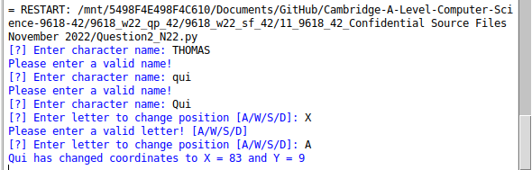

Question 3
Part 3(a)
Queue = [-1]*100 # integer
HeadPointer = -1 # integer
TailPointer = 0 # integer

Part 3(b)
def Enqueue(value) -> bool:
global Queue, HeadPointer, TailPointer
if TailPointer < 100:
if HeadPointer == -1:
HeadPointer = 0
Queue[TailPointer] = value
TailPointer = TailPointer + 1
return True
return False

Part 3(c)
for num in range(1, 21):
status = Enqueue(value=num)
if status:
print("Successful")
else:
print("Unsuccessful")

Part 3(d)
def ResucrsiveOutput(start: int) -> int:
global Queue

# base condition
if start == 0:
return Queue[start]
# recursive condition
else:
return Queue[start] + ResucrsiveOutput(start-1)

Part 3(e)(i)
print(ResucrsiveOutput(TailPointer-1))

Part 3(e)(ii)
